3rd Party Patching: PatchMyPC

Move updates to Server Packages (patch updates for all servers)

* Right click, Move.

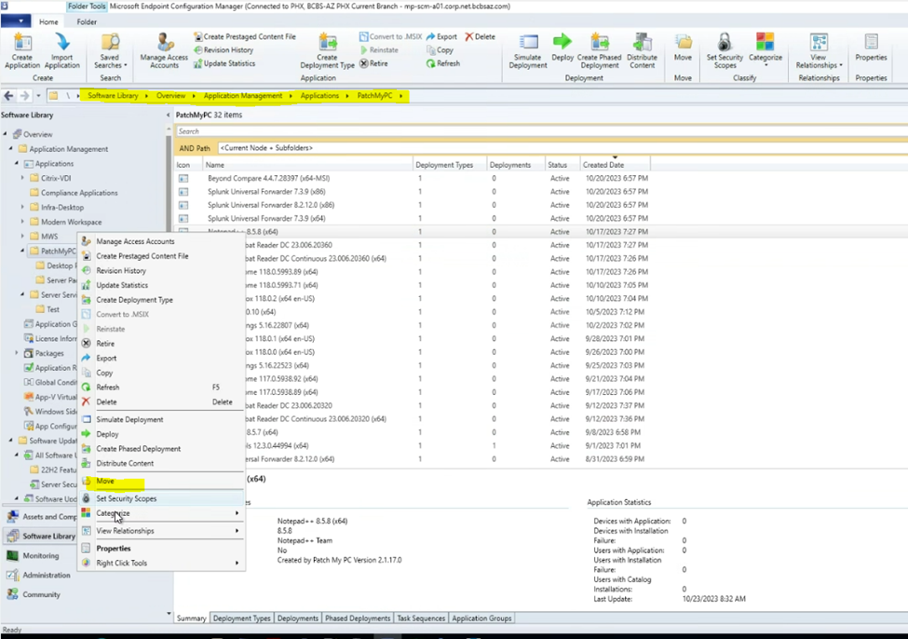

Deployment:

* Note: *Will need a Change Request if outside of the normal patching schedule.*

Setting up the deployment is the same as a regular deployment, however, there are a couple differences.

* Right-click/Deploy/Software Update
* Change to Software Updates

Using Wireshark as example:

* Type in Wire and click on the magnifying glass...
* Check the box and then click ok
  + *It is the same settings as a regular deployment*

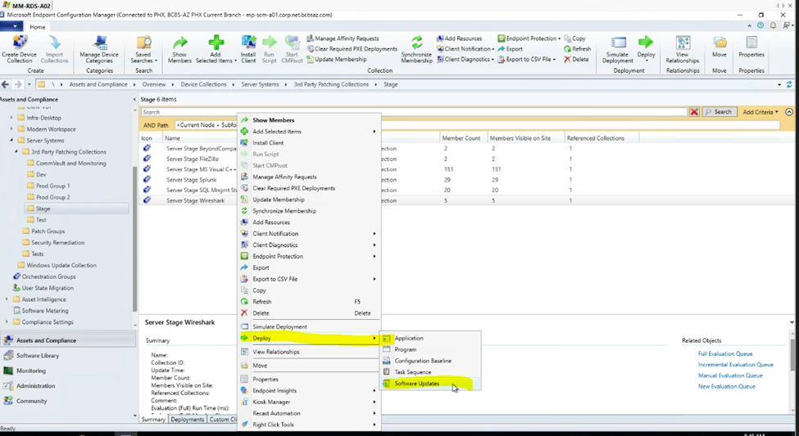

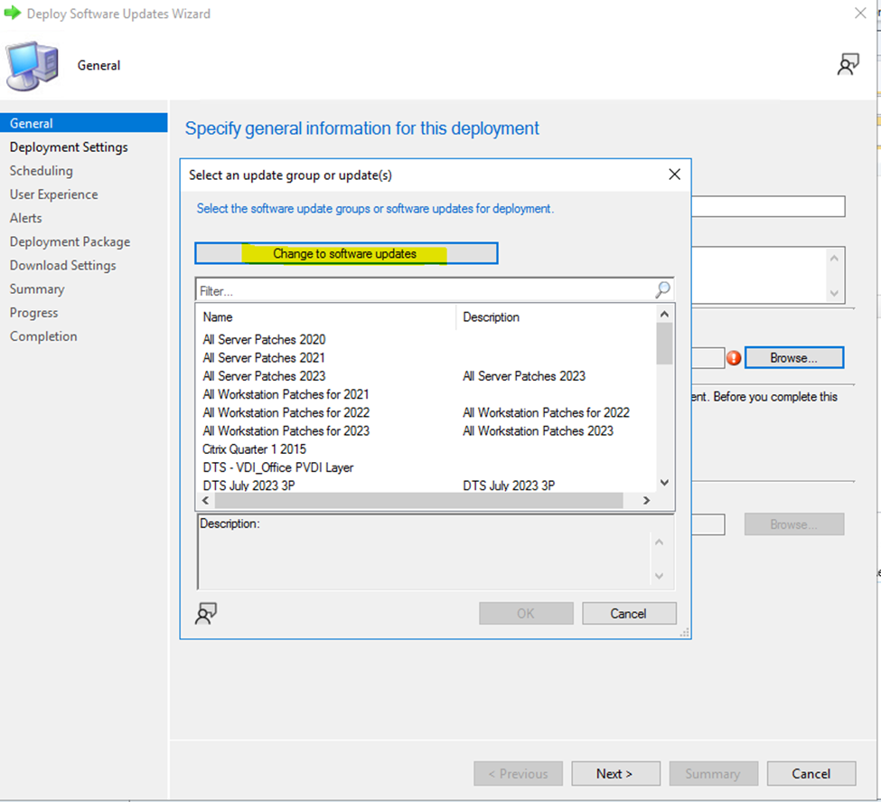

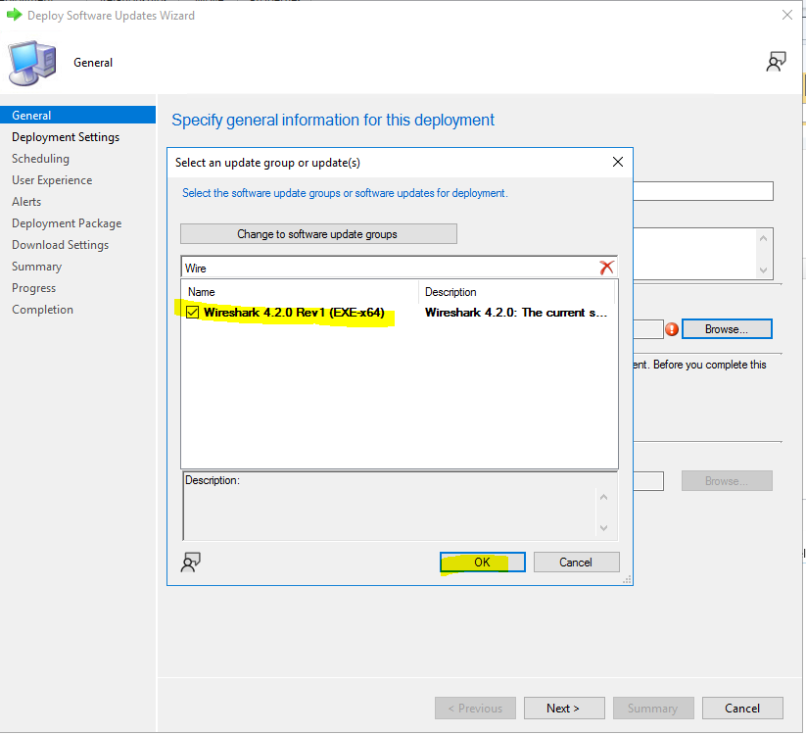

3rd Party Collection Groups in detail:

* CommVault and Monitoring
* Dev
* Prod Group 1
* Prod Group 2
* Stage
* Test

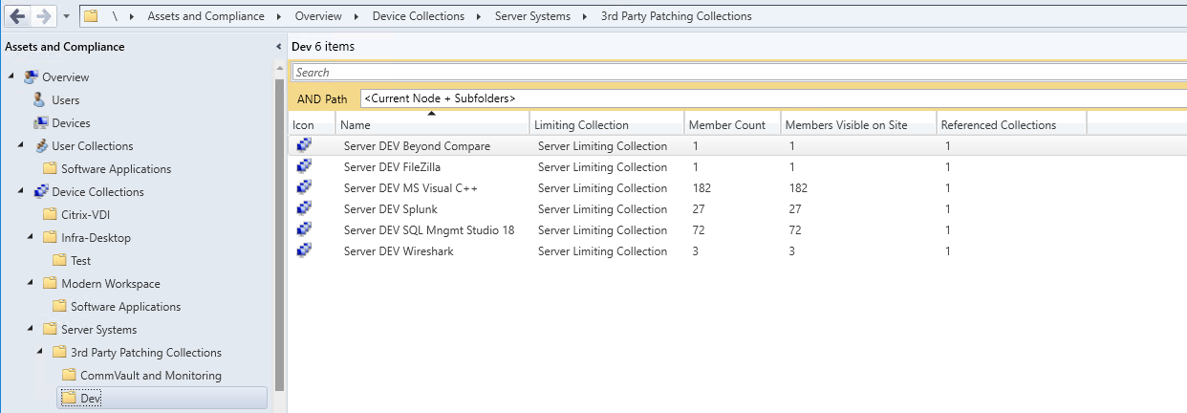

* \Assets and Compliance\Overview\Devices\Server DEV BeyondCompare
* \Assets and Compliance\Overview\Devices\Server DEV FileZilla
* \Assets and Compliance\Overview\Devices\Server DEV 1 MS Visual C++
* \Assets and Compliance\Overview\Devices\Server DEV Splunk
* \Assets and Compliance\Overview\Devices\Server DEV SQL Mngmt Studio 18
* \Assets and Compliance\Overview\Devices\Server DEV Wireshark

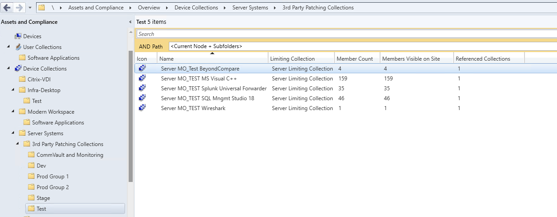

* \Assets and Compliance\Overview\Devices\Server MO_Test BeyondCompare
* \Assets and Compliance\Overview\Devices\Server MO_Test FileZilla
* \Assets and Compliance\Overview\Devices\Server MO_Test MS Visual C++
* \Assets and Compliance\Overview\Devices\Server MO_Test Splunk
* \Assets and Compliance\Overview\Devices\Server MO_Test SQL Mngmt Studio 18
* \Assets and Compliance\Overview\Devices\Server MO_Test Wireshark

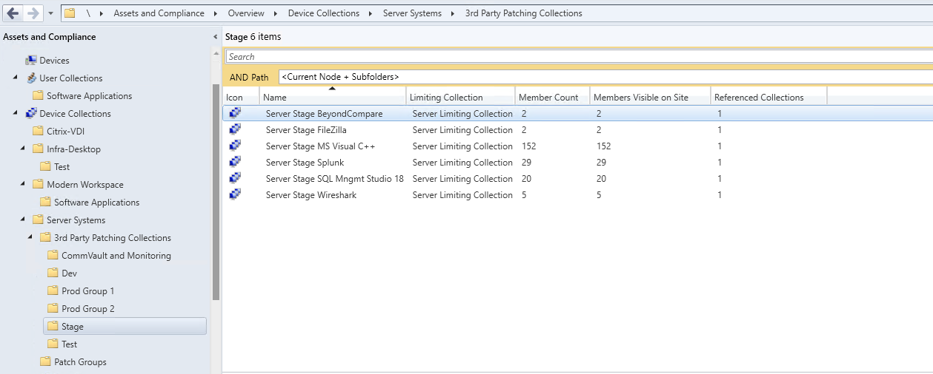

* \Assets and Compliance\Overview\Devices\Server Stage BeyondCompare
* \Assets and Compliance\Overview\Devices\Server Stage FileZilla
* \Assets and Compliance\Overview\Devices\Server Stage 1 MS Visual C++
* \Assets and Compliance\Overview\Devices\Server Stage Splunk
* \Assets and Compliance\Overview\Devices\Server Stage SQL Mngmt Studio 18
* \Assets and Compliance\Overview\Devices\Server Stage Wireshark

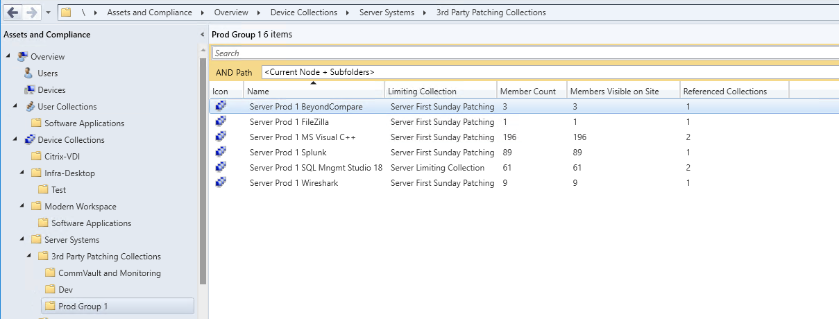

* \Assets and Compliance\Overview\Devices\Server Prod 1 BeyondCompare
* \Assets and Compliance\Overview\Devices\Server Prod 1 FileZilla
* \Assets and Compliance\Overview\Devices\Server PROD 1 MS Visual C++
* \Assets and Compliance\Overview\Devices\Server Prod 1 Splunk
* \Assets and Compliance\Overview\Devices\Server Prod 1 SQL Mngmt Studio 18
* \Assets and Compliance\Overview\Devices\Server Prod 1 Wireshark

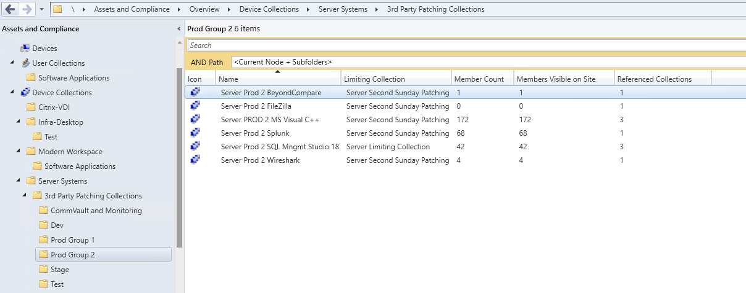

* \Assets and Compliance\Overview\Devices\Server Prod 2 BeyondCompare
* \Assets and Compliance\Overview\Devices\Server Prod 2 FileZilla
* \Assets and Compliance\Overview\Devices\Server PROD 2 MS Visual C++
* \Assets and Compliance\Overview\Devices\Server Prod 2 Splunk
* \Assets and Compliance\Overview\Devices\Server Prod 2 SQL Mngmt Studio 18
* \Assets and Compliance\Overview\Devices\Server Prod 2 Wireshark

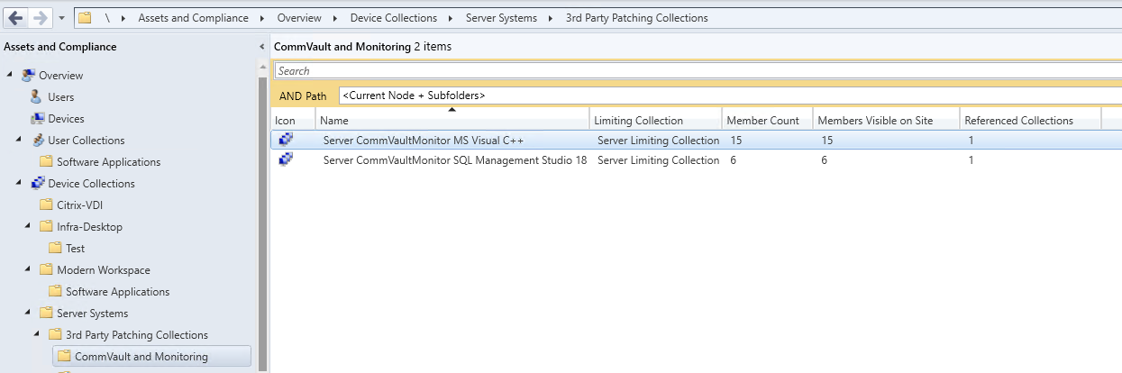

* \Assets and Compliance\Overview\Devices\Server CommVaultMonitor MS Visual C++
* \Assets and Compliance\Overview\Devices\Server CommVaultMonitor SQL Management Studio 18